Emotion and food analysis
Name:
University:
Lecturer:
Date:

Introduction
Emotion can be described as any conscious experience which is normally characterized by the activity of the mind and the mental activity results to pleasure or displeasure. Emotion is basically intertwined with motivation, disposition, personality, temperament and mood. Emotions are central tour day to day life. They dictate the relationship with colleague; they allow people to exist and to explore their destinies through motivating people towards the destiny. Emotion determine what a person can achieve in life such that negative emotionally people see life as useless while positive emotionally people are excited about the life and are eager to conger the challenges ahead of them. There is close relationship between food and emotions. Certain food triggers positive emotions while other food triggers negative emotions. In this essay, I will (1) Choose five emotions in the attached file (2) write a detailed description of each emotion (3) Choose the photograph of food or drink that best symbolizes the emotion and finally (5) explains in details why I choose each image.
The 5 Emotions I Choose
I choose the following 5 emotions and I believe that the emotions I chose plays an important role in the discussions which I am about to make. I made the choices because they shape my day to day life and by shading more light to such emotions, I will be able to understand more about life. The emotions are
- Happiness
- Love and Passion
- Anger
- Jealousy
- Social Anxiety
Detailed description of each emotion
Happiness
Happiness is one of the most common emotions experienced by people in a day to day basis. It is a state of cheer, pleasure, joy and contentment. Happy mental is normally reflected by the judgment made by a person about the overall wellbeing. Human being experience happiness when there is absence of negative emotions and the triumph of positive emotion. Any activity which is done with the approach of positive mindset results to happiness brings laughter, joy, serenity love and joy. Happiness is a virtue which triggers humanity to develop positive relationship with one another for common good.
Love and Passion
Love and passion are extra ordinary emotions which influence people to act in a certain way. Love simply implies to feeling attracted and committed to someone else, it means caring and heartily pleasure. On the other hand, passion includes intimacy, excitement and attraction to one another. According to studies, the factors that influence love and passion include timing whereby one person is ready to be in love with one another, early attachments to style where secured individuals develops deeper love and passion and similarity where people to love people who are relatively good, affectionate, personable and those who resembles them in varieties of ways.
Anger
Anger is an emotion which is characterized by retribution, malice or agitation. In simpler terms, anger is response to being wronged. Anger gives people a way of expressing negative feelings or in some cases, it motivates people to find solutions to problems. For example, if you accidentally delete all files in computer and cannot recover back, one will become very angry. Such anger, as a result of deleting important files will motivate the person come up with long lasting solution of protecting files. Therefore, anger is like double edged sword which has positive and negative implications.
Jealousy
Jealousy is an emotion which basically refers to the feelings of thoughts which consists of fear, insecurity, concern and envy which results from relative lack of status, possession or something of personal value especially in reference to comparator. Jealousy cause people to underrate others through developing negative feelings of what such people have. For example, when one student gets better grade than fellow students, then the students who get low grades becomes jealousy. On the contrary, jealousy serves good for couples who are in relationship. Their love is guarded and sealed by jealousy, the process which will not give room third-party.
Social Anxiety
It is the fear which arises due to not making good signals and impression to other people. People who suffer from social anxiety tend to develop fear, anxiety, embarrassment and self-consciousness. Social anxiety is like a disease whose symptoms include excess fear of situation, excess worry related to embarrassment and the general humiliation. To resolve the social anxiety, talk therapy is essential as it gives hope to the affected person.

The photograph of food or drink that best symbolizes the emotion and reasons for choosing each image
Happiness
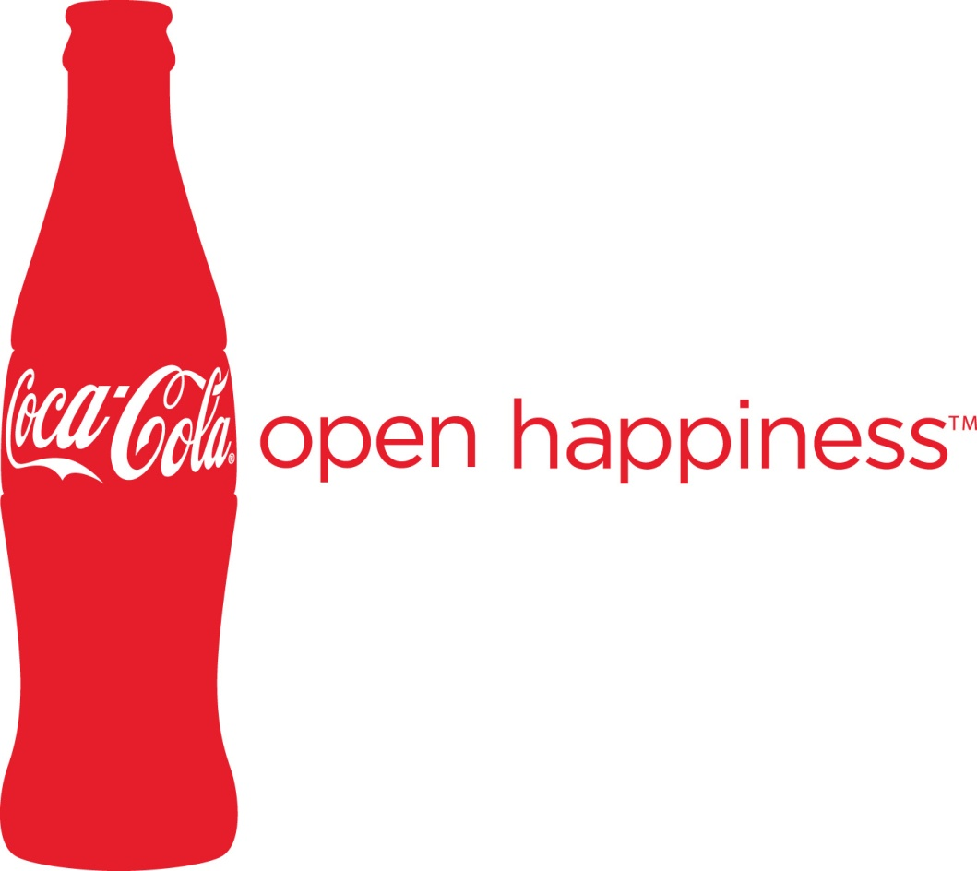

I used the above drinks of Coca-Cola drinks because over the years, I have related the happiness to Coca-Cola to happiness. The happy emotional attachment of the drink might be result of organization which market the product and relate it to happiness. Indeed whenever I drink, there is a great feeling of refreshment.

Love and Passion
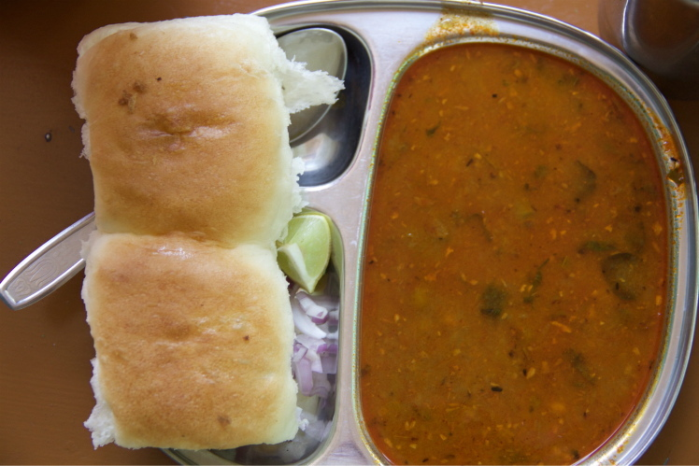

I chose the above photo of pan cake because cakes symbolize love. The cake is sweet and the sweetness part of eat is experience similar to love and passion. The cakes are normally used in wedding celebration since it symbolizes maximum affection through love and passion.

Jealousy

Jealousy is characterized by expensive drinks afforded by few people in the society. In my opinion, it is unfair for few sections of people to purchase expensive drinks which its considerable unaffordable to many people. Therefore, the feeling of jealousy is experienced by few people who felt that they have been left out.
Anger

Anger is characterized by the intake of alcoholic drinks as indicated in the above picture. Anger stimulates negative feelings. In my life, I have experienced people fighting after taking alcohol, causing accidents, family break ups among many more other negative emotions.

Social Anxiety
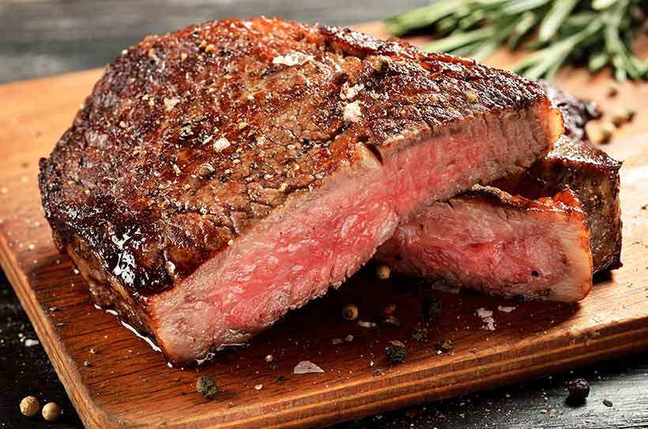

The above drink symbolizes social anxiety. I chose the picture of such food because w1hen people eat such food in junk for a long period of time, they will develop blood pressure, diabetes and in some cases heart failure.

Reference
Fox, Elaine (2008). Emotion Science: An Integration of Cognitive and Neuroscientific Approaches. Palgrave MacMillan: USA
Roberts, Robert. (2003). Emotions: An Essay in Aid of Moral Psychology. Cambridge: Cambridge University Press.

